(a) Ramesh’s basic salary is input through the keyboard. His dearness allowance is 40% of basic

salary, and house rent allowance is 20% of basic salary. Write a program to calculate his gross salary.

Chapter 1: Getting Started 47

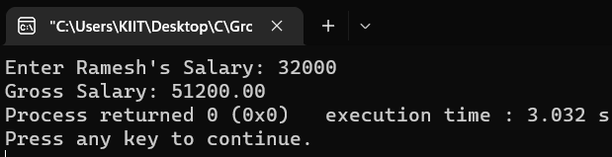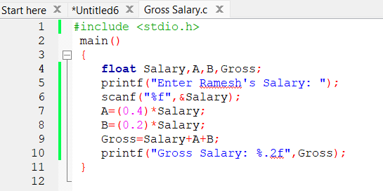Code:   
Output:

(b) The distance between two cities (in km.) is input through the keyboard. Write a program to

convert and print this distance in meters, feet, inches and centimetres.

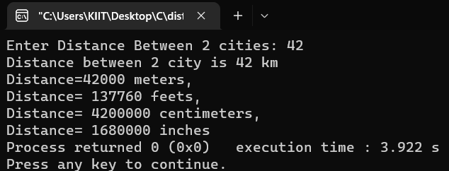Code: 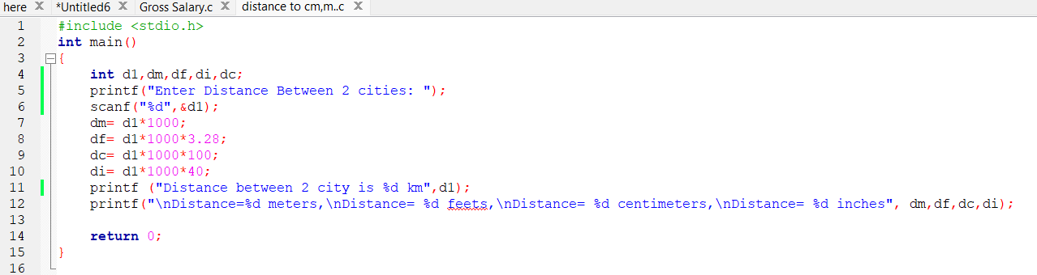  
Output:

(c) If the marks obtained by a student in five different subjects are input through the keyboard, find

out the aggregate marks and percentage marks obtained by the student. Assume that the maximum

marks that can be obtained by a student in each subject is 100.

REPEATED

(d) Temperature of a city in Fahrenheit degrees is input through the keyboard. Write a program to

convert this temperature into Centigrade degrees.

REPEATED

(e) The length & breadth of a rectangle and radius of a circle

are input through the keyboard. Write a

program to calculate the area & perimeter of the rectangle, and the area & circumference of the

circle.

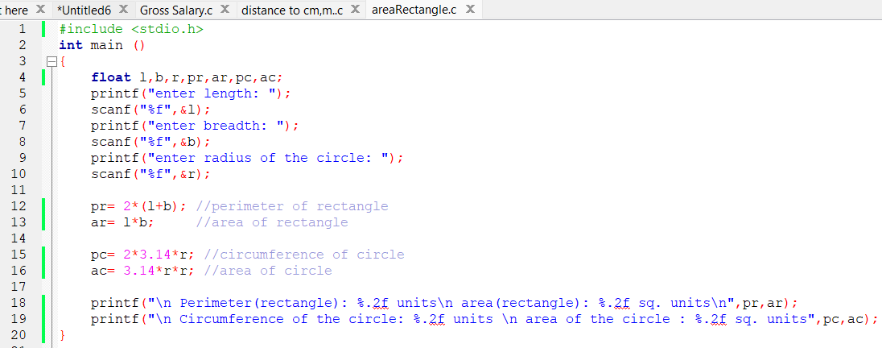Code: 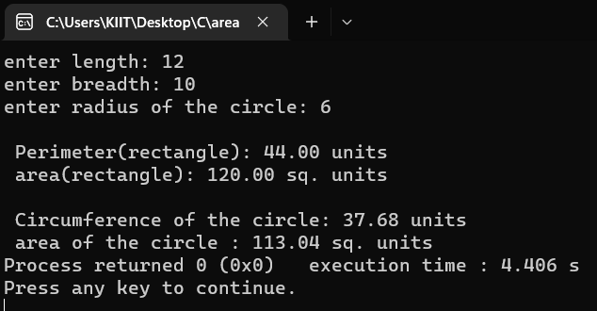  
Output:

(f) Two numbers are input through the keyboard into two locations C and D. Write a program to

interchange the contents of C and D.

Repeated

(g) If a five-digit number is input through the keyboard, write a program to calculate the sum of its

digits. (Hint: Use the modulus operator ‘%’)

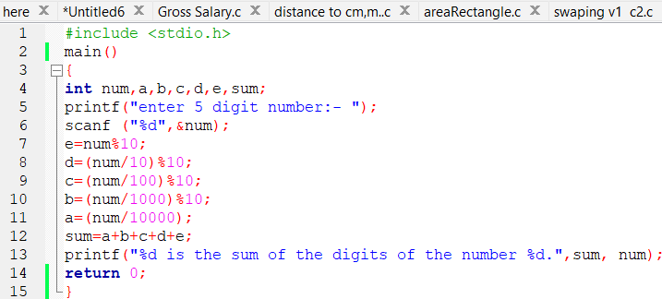Code:

Output:

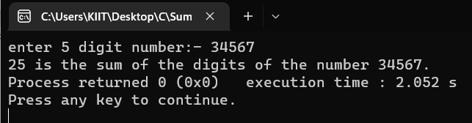

(h) If a five-digit number is input through the keyboard, write a program to reverse the number.

REPEATED

(i) If a four-digit number is input through the keyboard, write a program to obtain the sum of the

first and last digit of this number.

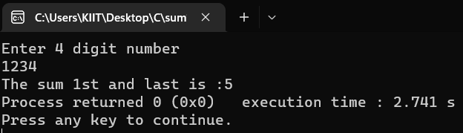Code: 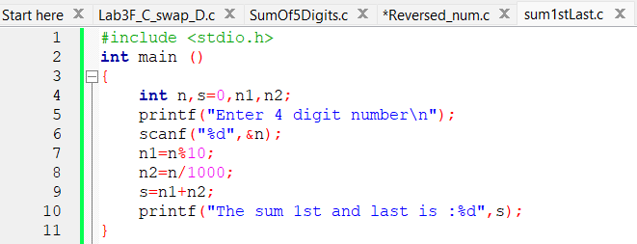  
Output:

(j) In a town, the percentage of men is 52. The percentage of total literacy is 48. If total percentage

of literate men is 35 of the total population, write a program to find the total number of illiterate men and women if the population of the town is 80,000.

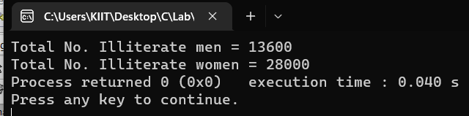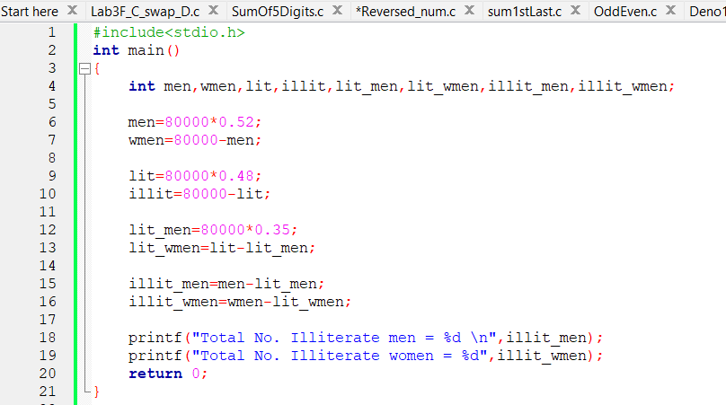Code:   
Output:

(k) A cashier has currency notes of denominations 10, 50 and 100. If the amount to be withdrawn is

input through the keyboard in hundreds, find the total number of currency notes of each

denomination the cashier will have to give to the withdrawer.

Code: 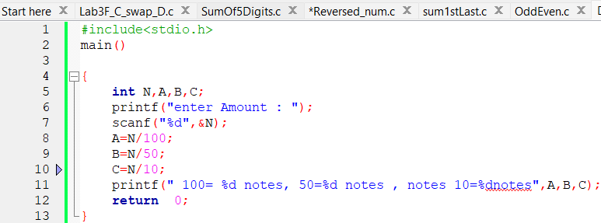  
Output: 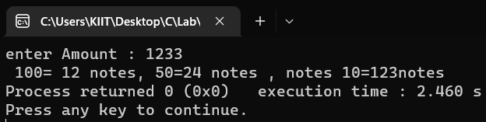

(l) If the total selling price of 15 items and the total profit earned on them is input through the

keyboard, write a program to find the cost price of one item.

Code: 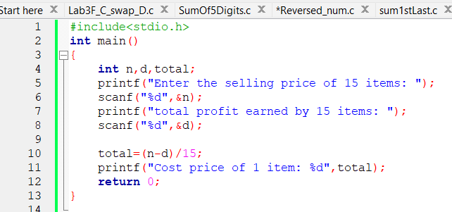  
Output: 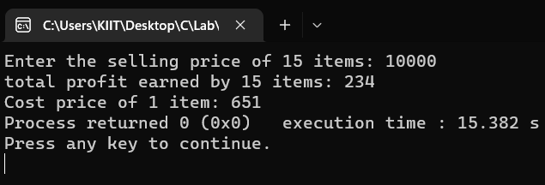

(m) If a five-digit number is input through the keyboard, write a program to print a new number by

adding one to each of its digits.

For example if the number that is input is 12391 then the output

should be displayed as 23402.

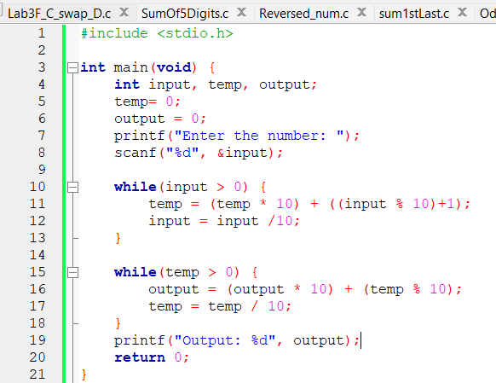Code:

Output:

